Gant chart
Figure 1 shows a Gantt chart that visually represents the timeline of various project tasks from November to January. Each row corresponds to a specific task, and the colored bars indicate the duration and timing of each activity. The project is divided into six main phases: finding idea, project planning, lecture review, methodology, revision and final review, and the documentation phase is conducted continuously throughout the entire project duration.
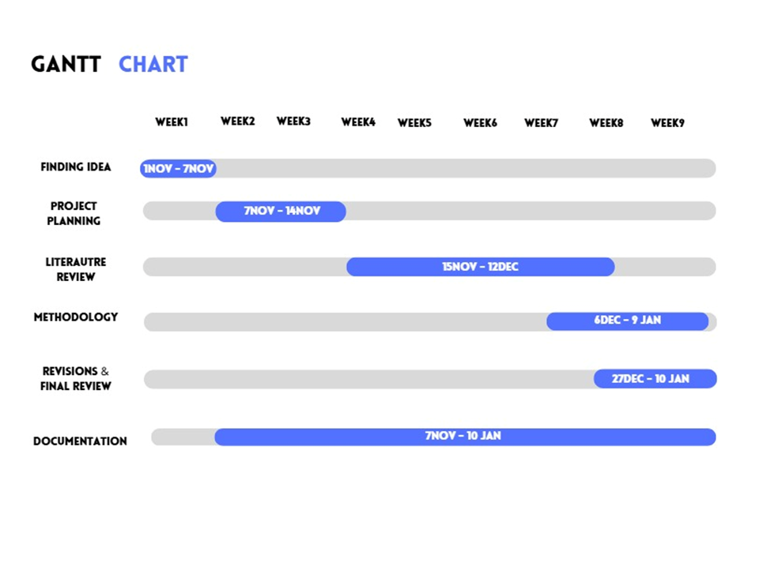
Figure 1:Gant Chart

planning
The planning phase of the FixIt Jo project focuses on organizing the development process and defining the steps required to build the application successfully.
First, the system requirements are identified, including user registration, service booking, technician management, and rating features. Then, the project tasks are divided into stages such as design, development, testing, and deployment.
A timeline is created to ensure that each phase is completed on time. The project also assigns responsibilities, where developers focus on coding, designers handle the user interface, and testers ensure system quality.
Tools such as Flutter will be used for application development, and a database system will be implemented to manage users and bookings.
Overall, proper planning ensures that the project is completed efficiently, within time, and meets user needs.

